CUSTOM BOOTCAMP
Azure SQL

Creating Table
- CREATE TABLE SALES_AGENTS(ID NUMERIC PRIMARY KEY, LAST_NAME VARCHAR(15), FIRST_NAME VARCHAR(15), GALLERY_ID NUMERIC, AGENCY_FEE DECIMAL);
- CREATE TABLE MANAGERS(ID NUMERIC PRIMARY KEY, GALLERY_ID NUMERIC);

Inserting Data into Tablex
- INSERT INTO MANAGERS VALUES(1, 2);
- INSERT INTO MANAGERS VALUES(2, 3);
- INSERT INTO MANAGERS VALUES(4, 1);
- INSERT INTO SALES_AGENTS VALUES(1, 'Brown', 'Dennis', 2, 2050);
- INSERT INTO SALES_AGENTS VALUES(2, 'White', 'Kate', 3, 3120);
- INSERT INTO SALES_AGENTS VALUES(3, 'Black', 'Sarah', 2, 1640);
- INSERT INTO SALES_AGENTS VALUES(4, 'Smith', 'Helen', 1, 4500);
- INSERT INTO SALES_AGENTS VALUES(5, 'Stewart', 'Tom', 3, 2130);

Sales Agents
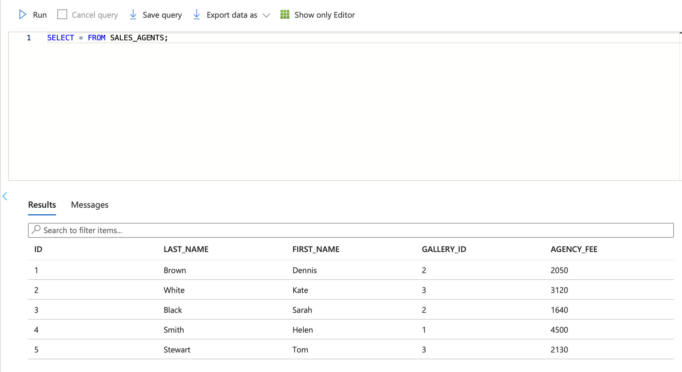
Managers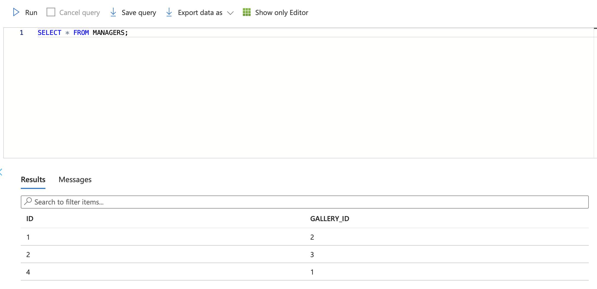

Galleries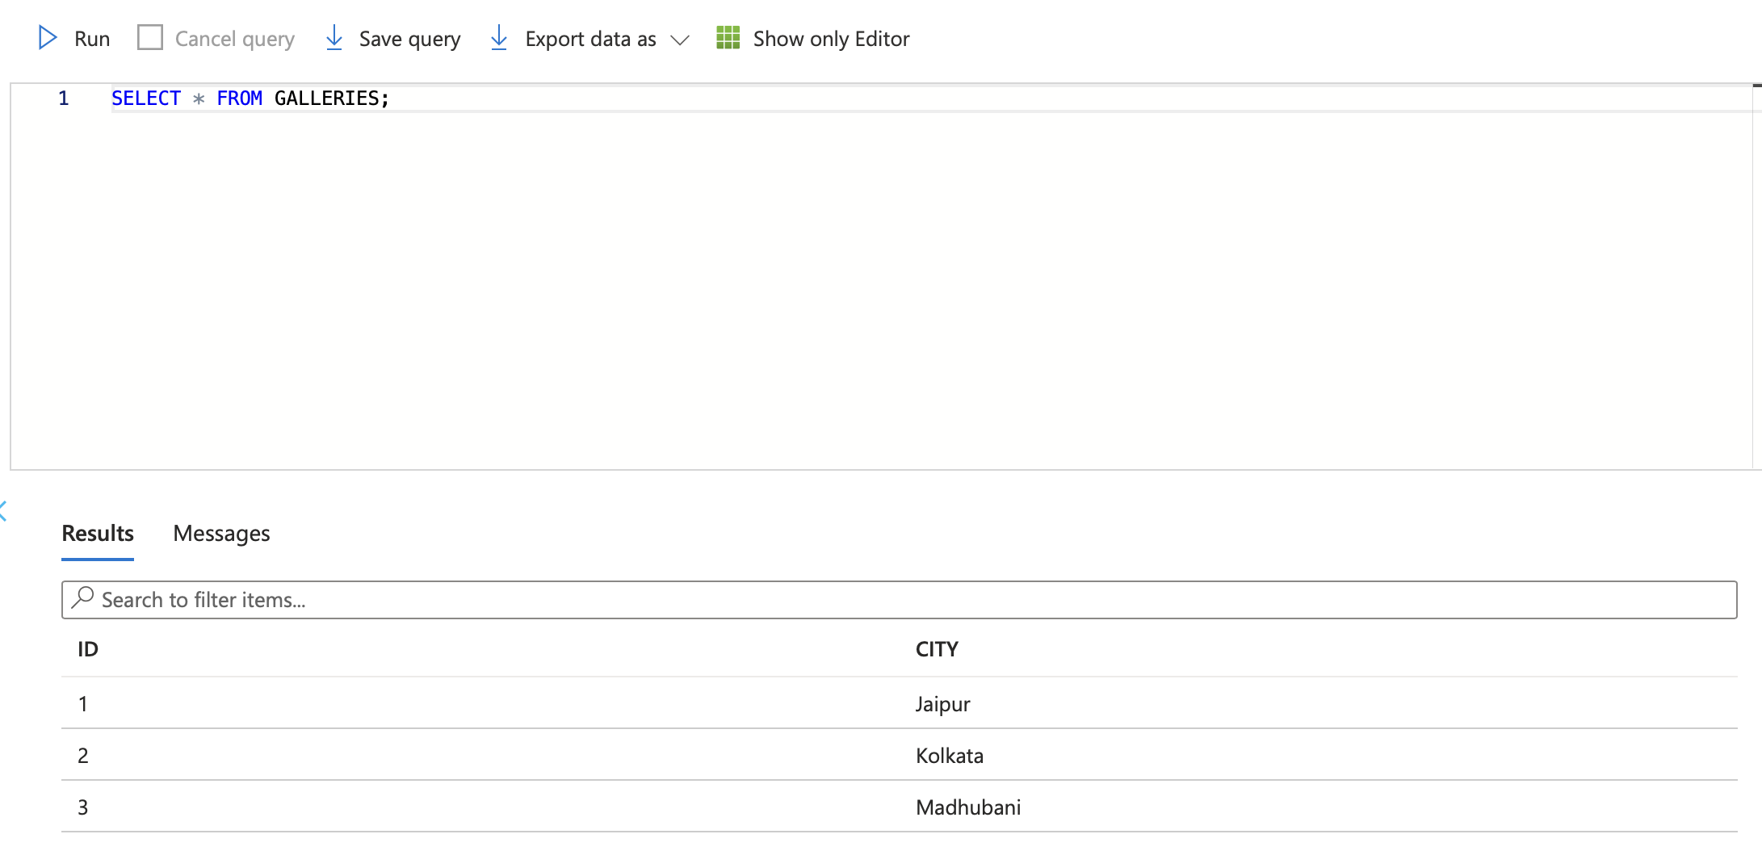
Paintings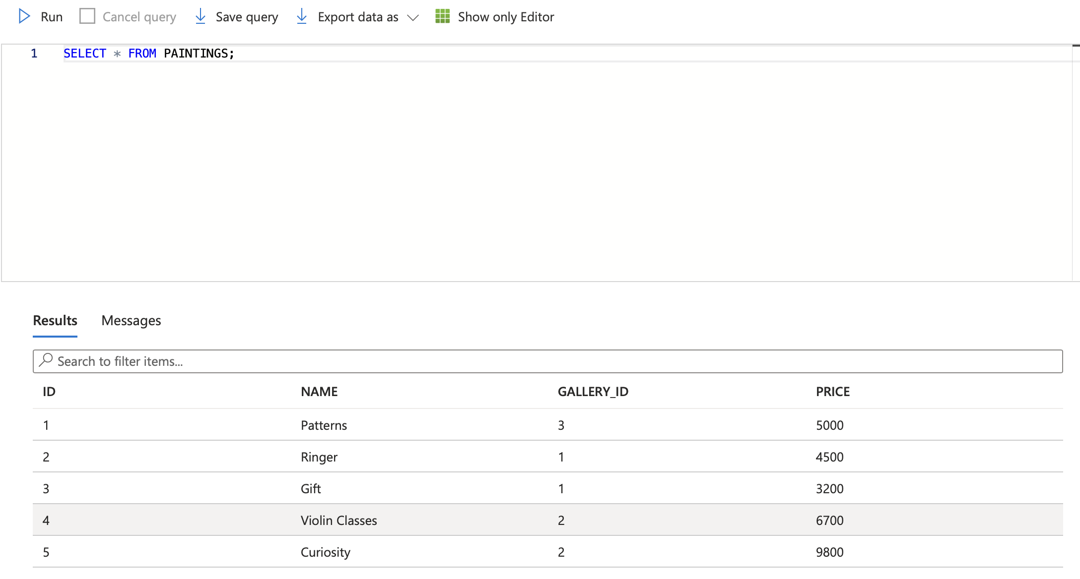

Stored Procedure
- It is a group of SQL statements that are stored in the database and can be executed as a single unit.
- They are often used for tasks such as data manipulation, data validation, and other business logic operations.

Function
- Similar to stored procedures but return a value.
- Can be used to perform calculations, retrieve specific data, or transform data thin a query.

Differences between Stored Procedures and Functions
- Return Value: Stored Procedures can have output parameters, but they don’t necessarily return a value but Functions must return a value.
- Usage in Queries: Stored Procedures can be used to perform actions like updating data and functions are used in queries to retrieve values like a column value or a computed result.
- Transactions: Stored Procedures can participate in transactions whereas functions generally do not participate.
- Control Flow: Stored Procedures can. Have more complex control flow

Types of Subquery
- Correlated
- Nested
- Single Row
- Multiple Row
- Multiple Column

Single Row Subquery
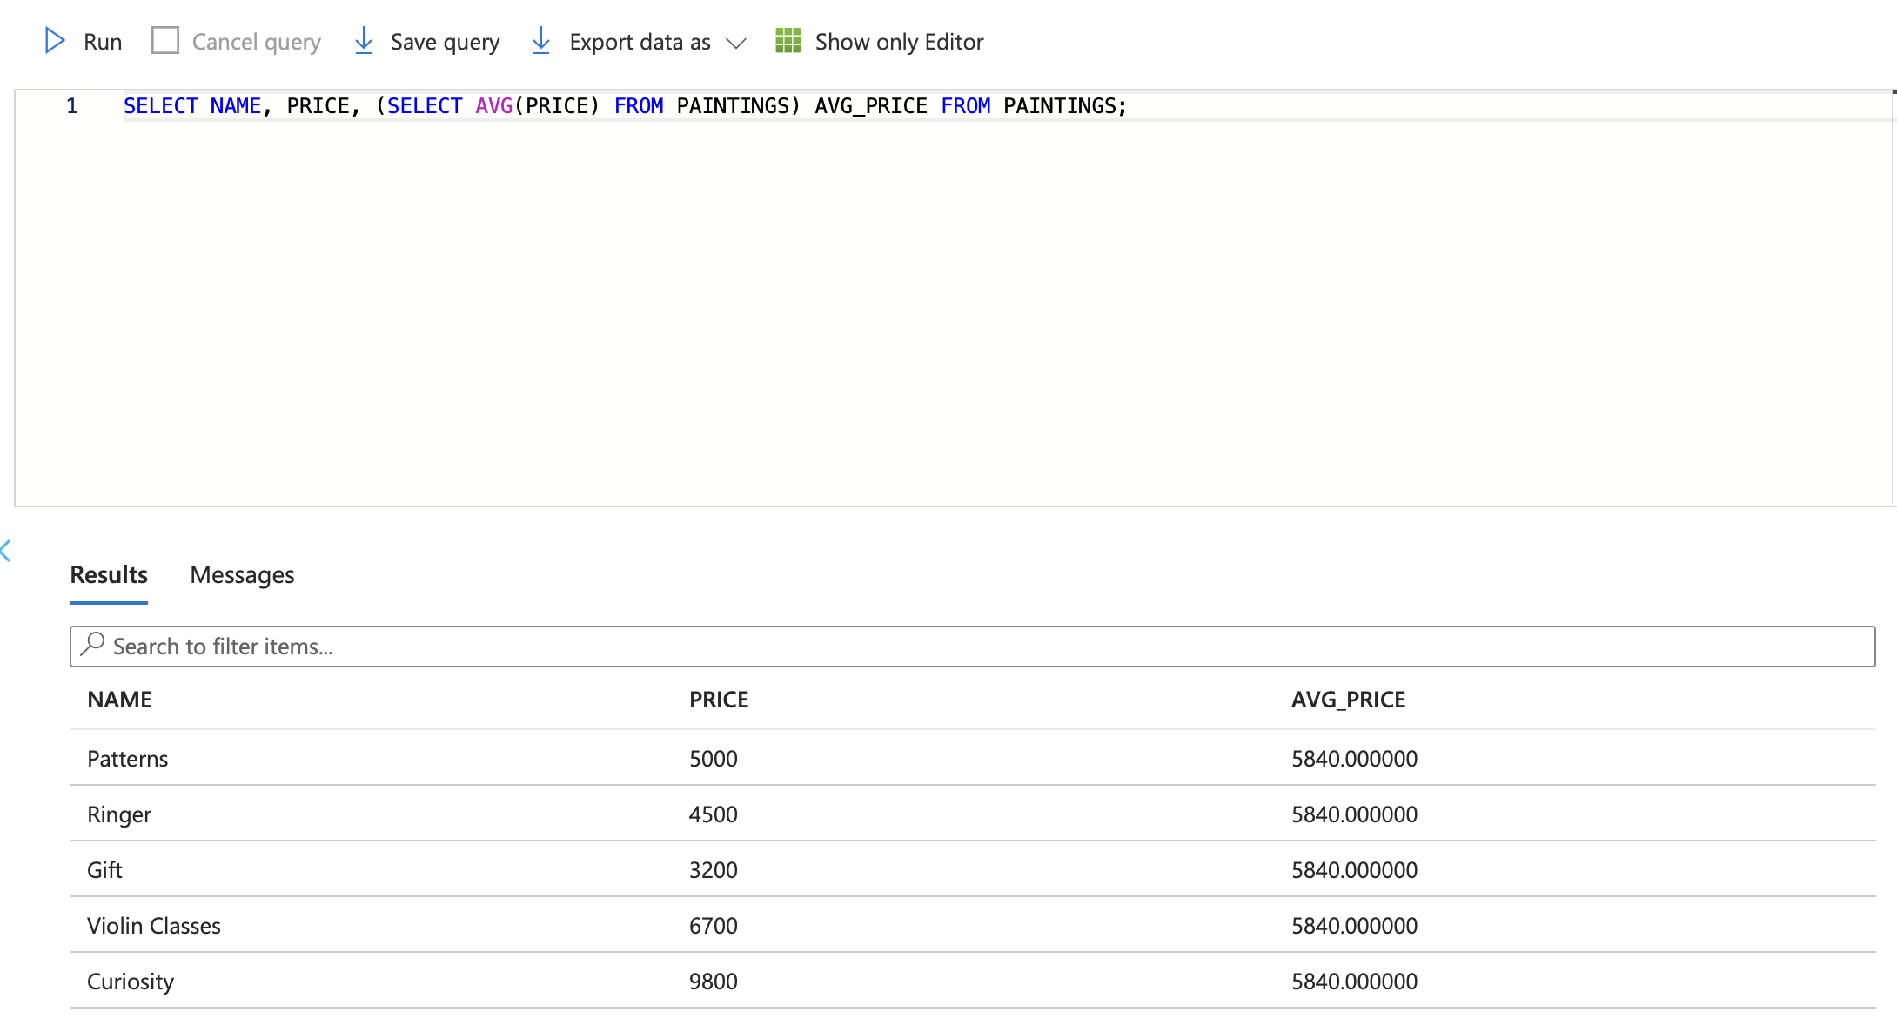
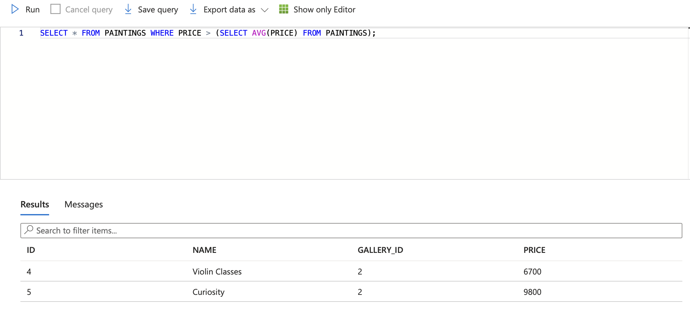

Multiple Row Subquery
Subqueries that return multiple rows as an output to their parent query are called multiple row subqueries.

Example:
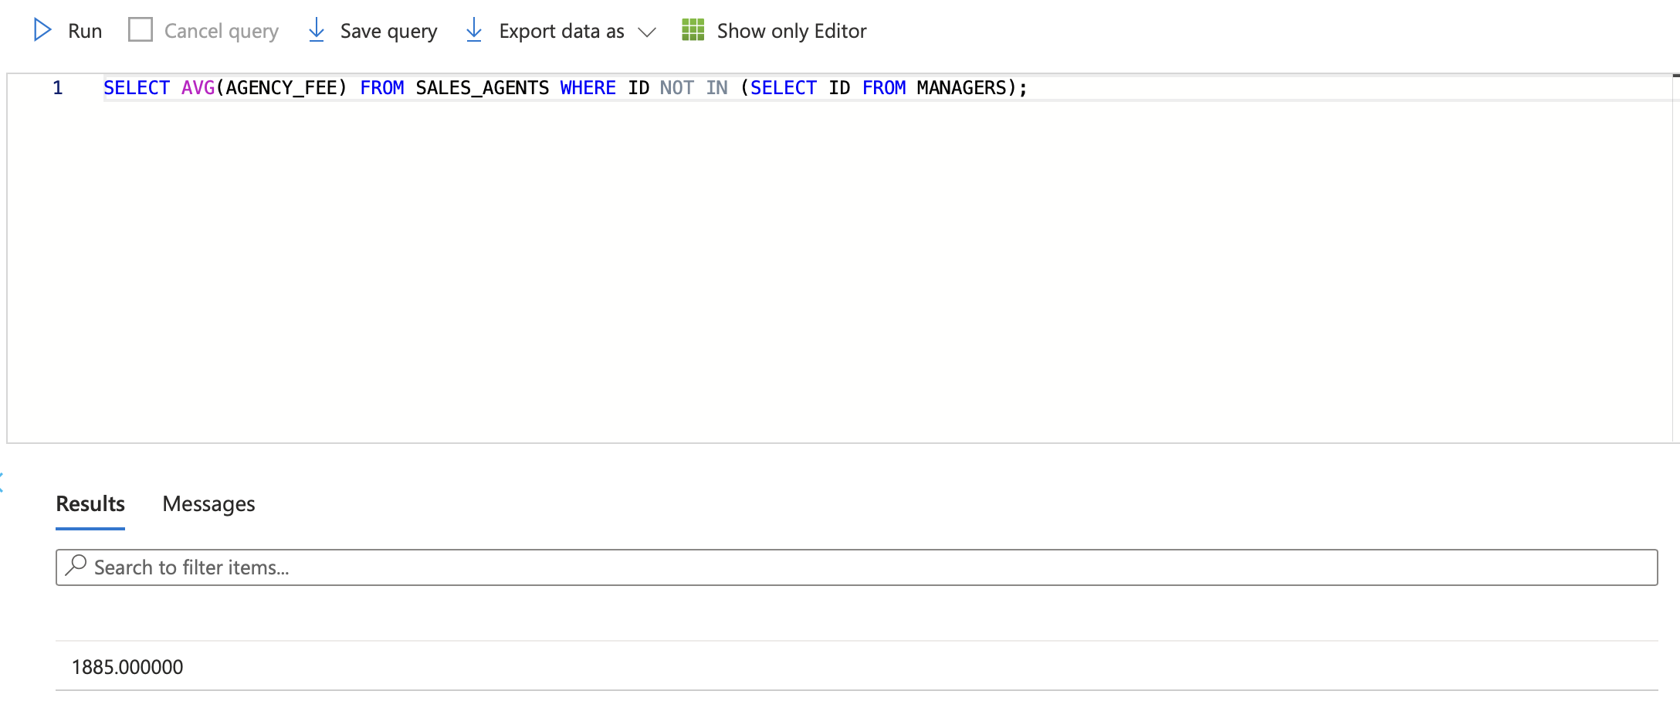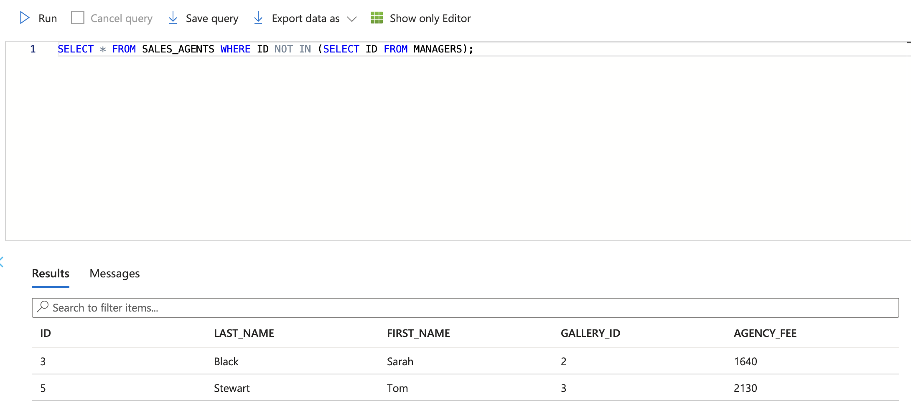

Multiple Column Subquery
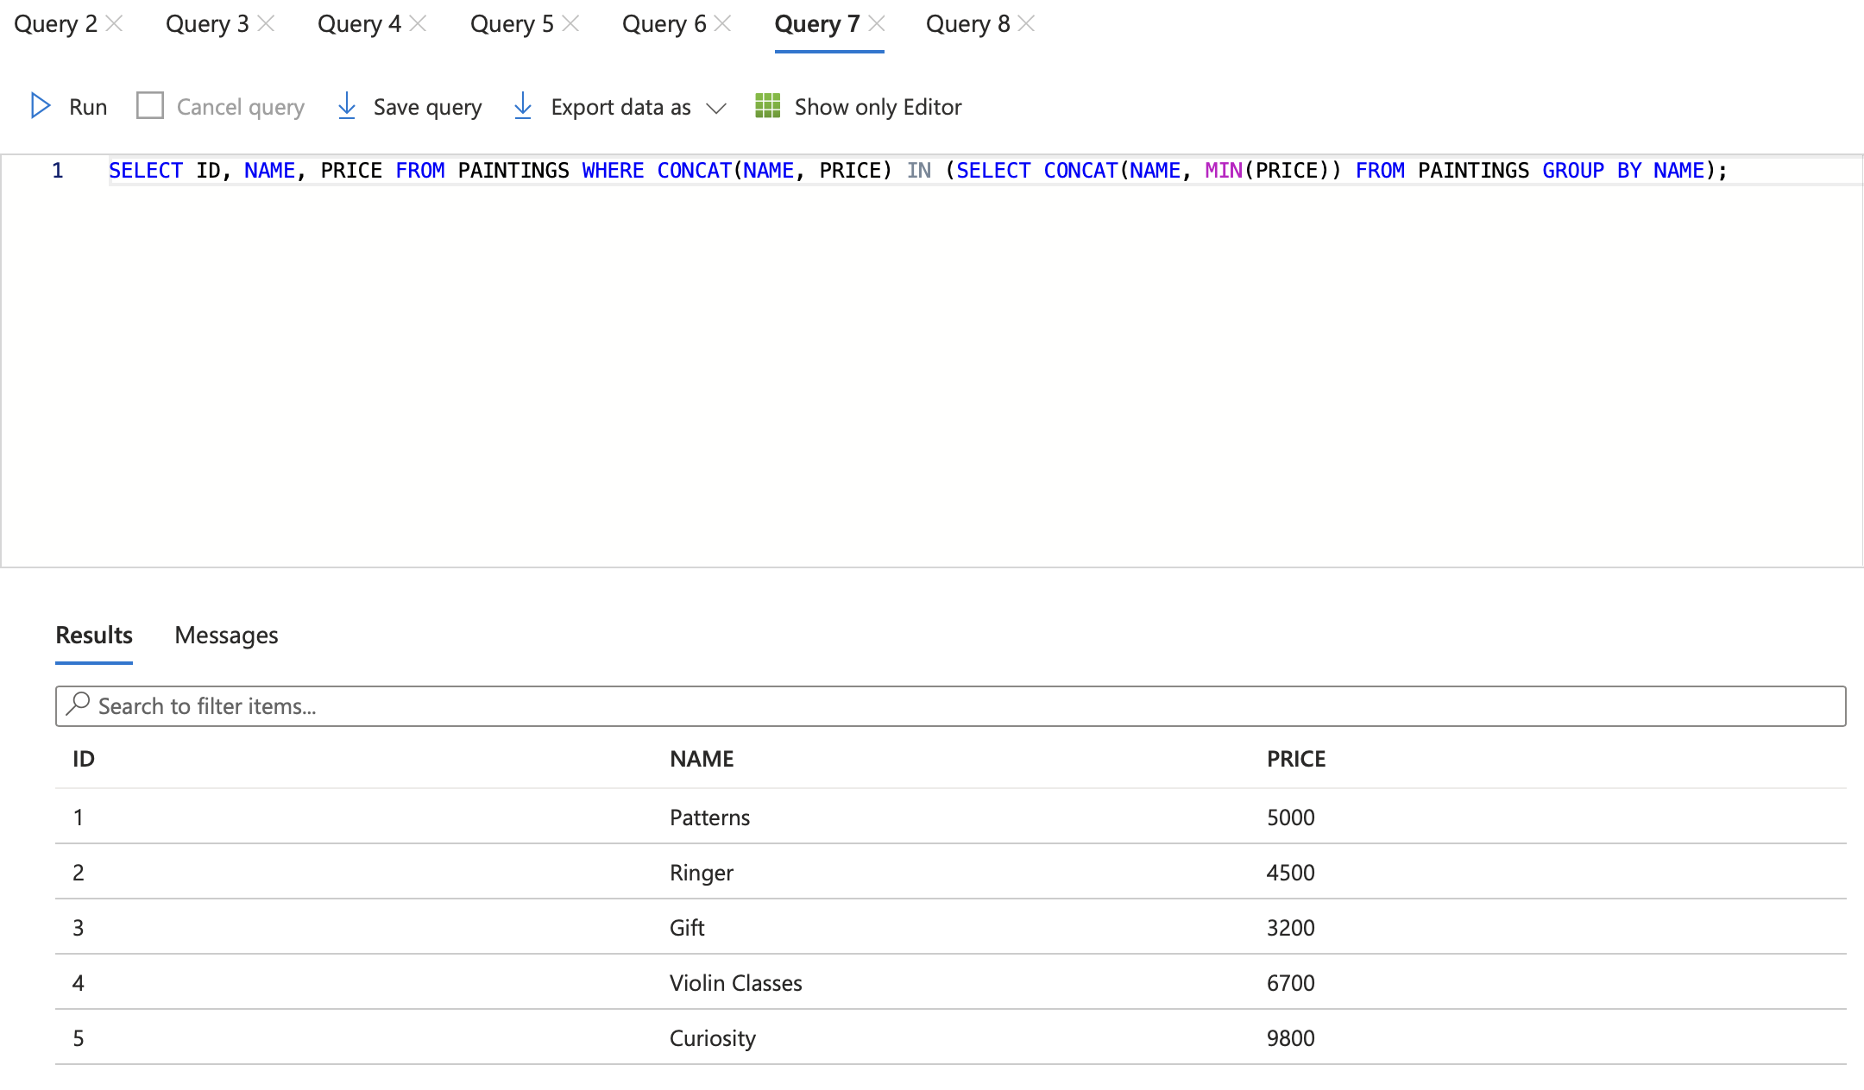

Correlated Subquery
Subqueries that return multiple columns as output depending on the information obtained from the parent query are called correlated subquery.
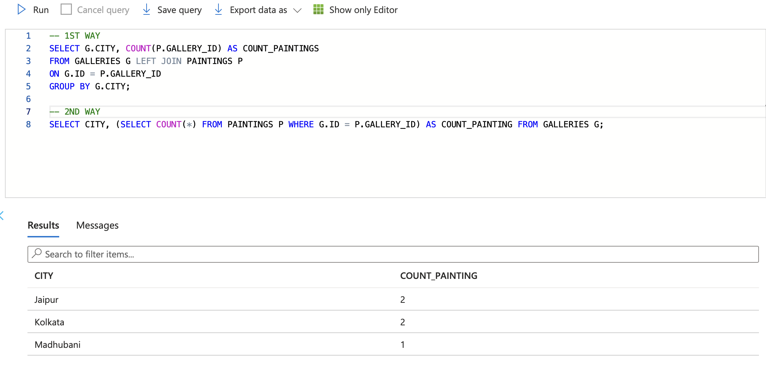
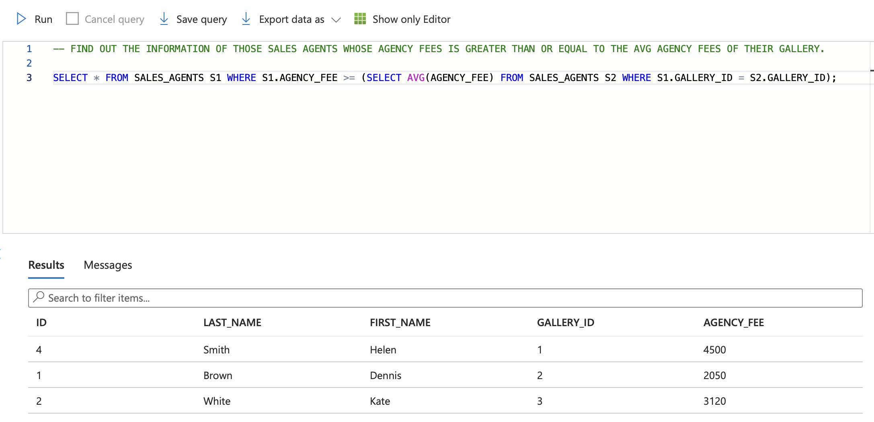

Nested Subquery
Subqueries that are inside subqueries are known as nested subqueries.
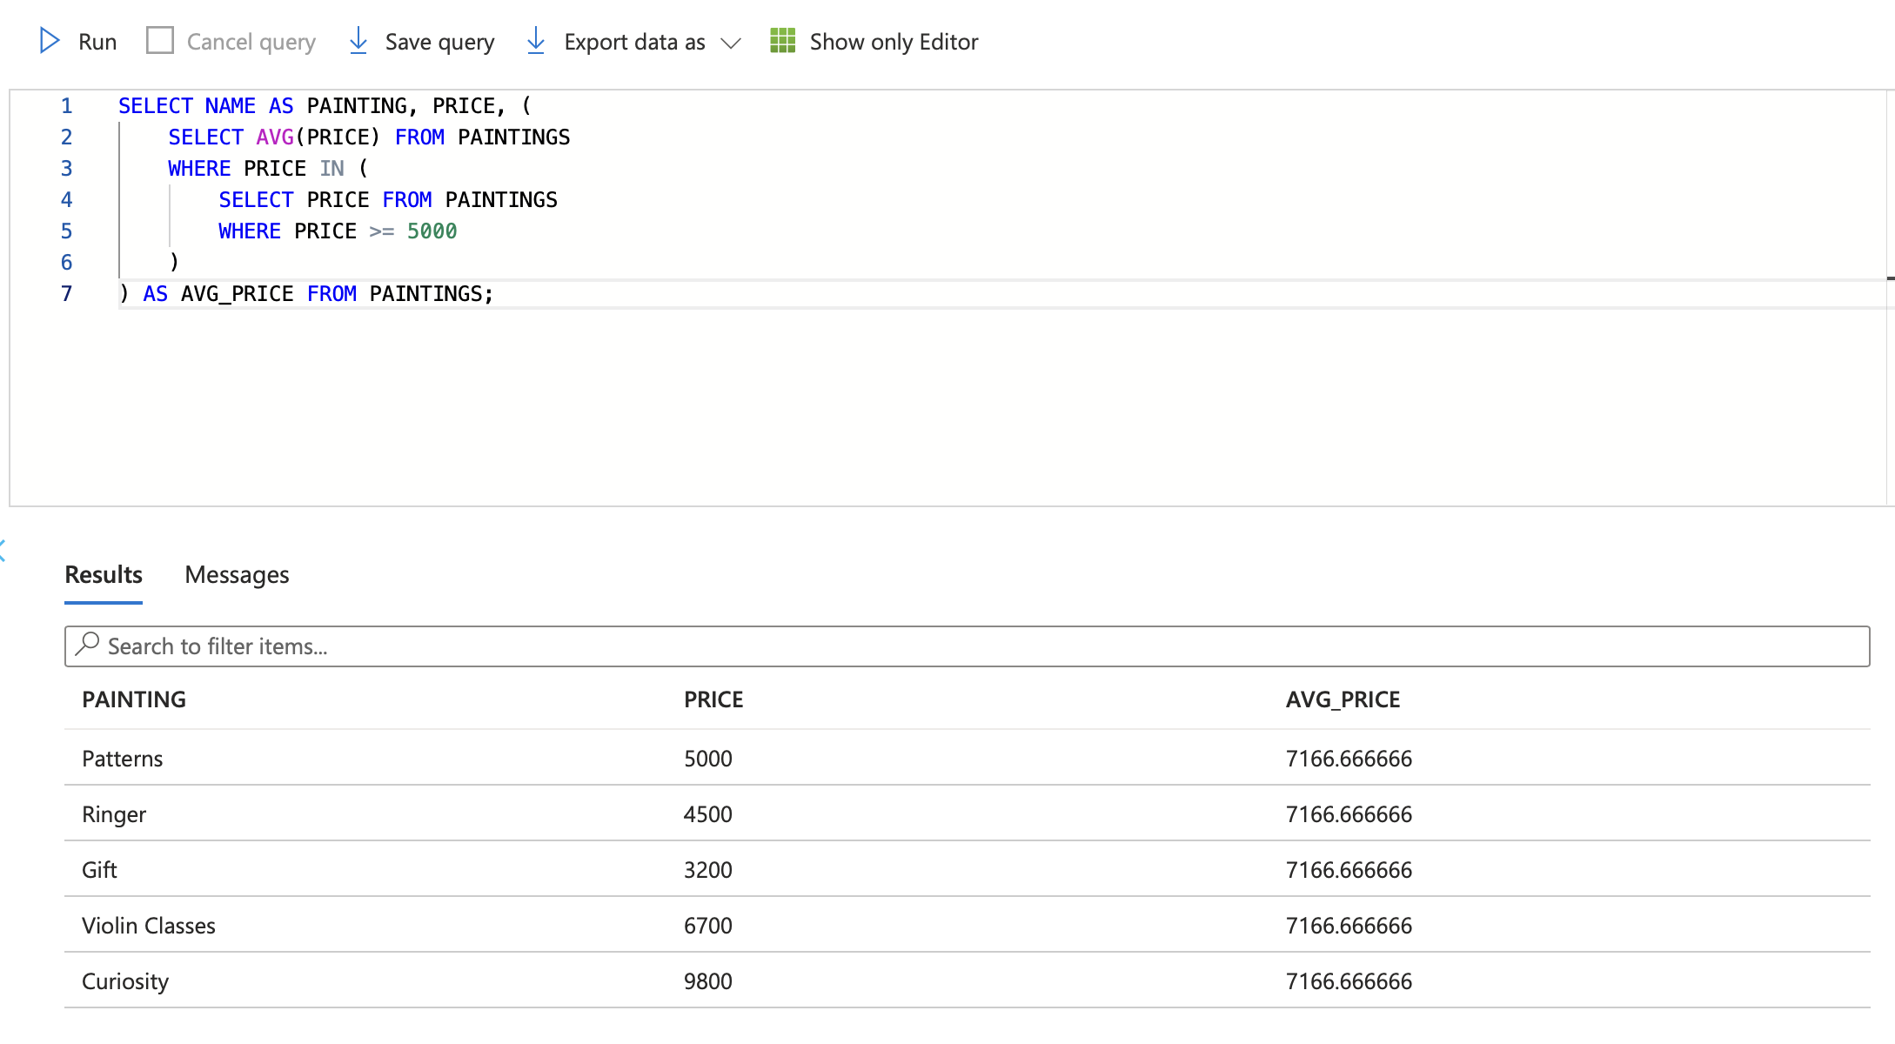

View
- A Virtual table that is based on the result of the select query
- Provide a way to simplify complex queries, encapsulate logic, and control access to the underlying data.’
- Syntax: CREATE VIEW <VIEW_NAME> AS SELECT………
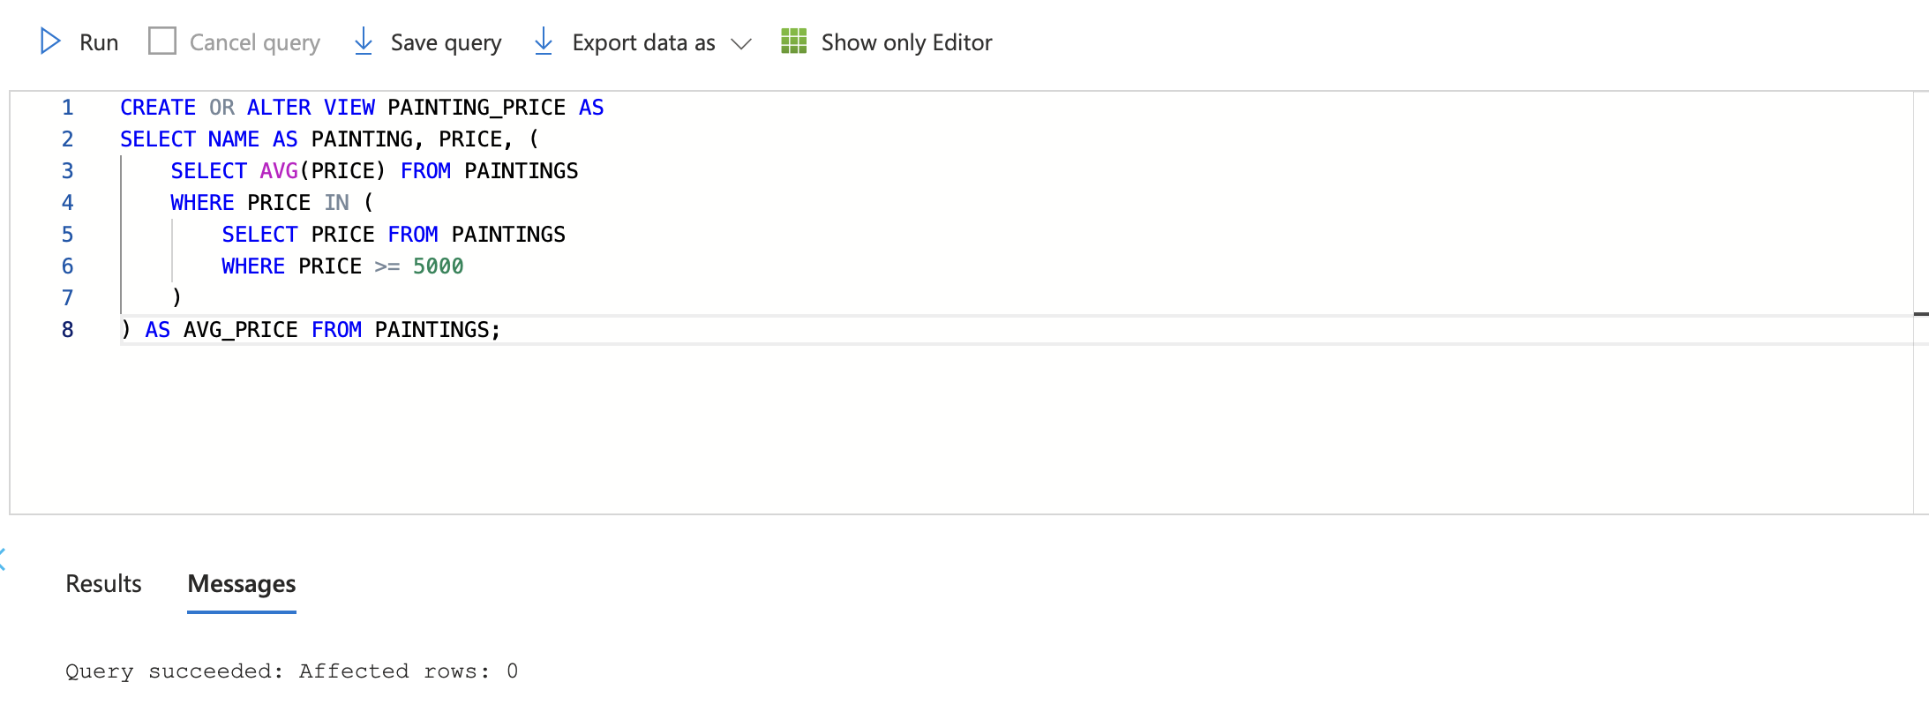
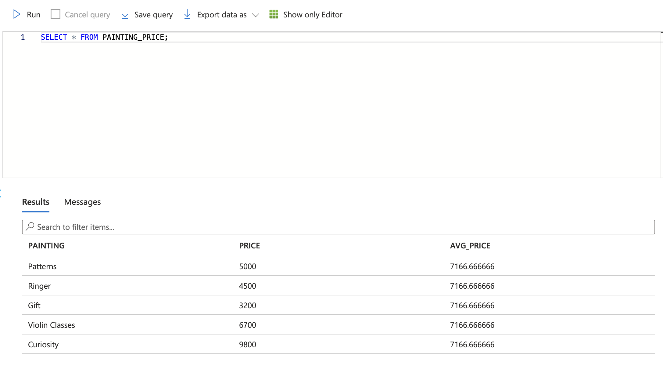

Benefits of Views
- Simplicity
- Security
- Encapsulation
- Consistency
- Performance

Indexes
- Database structures that improve the speed of data retrieval operations on tables.
- They provide a way to quickly locate rows based on the values in one or more columns.
- The different types of indexes are heaps, clustered, non-clustered, and column store.

Clustered Index
- Determines the physical order of data in a table.
- Each table can only have one clustered index because it defines the physical storage order of the data rows.
- A clustered index can significantly speed up retrieval operations on the indexed column(s).
- Syntax: create clustered index <index_name> on <table_name> (column1, column2, ….);

Non-Clustered Index

Columnstore Index
- It is designed to improve data retrieval for analytical queries by storing column data together, instead of storing rows together as in traditional indexes.

